**Basic proposal – subsector and regional trends**

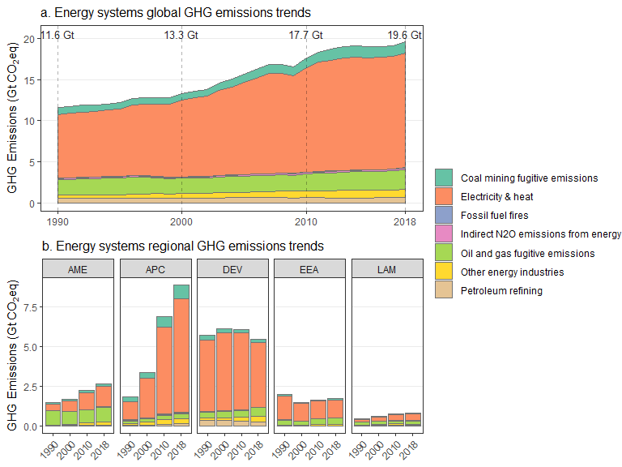

**Could also include:**

* Aggregate growth rates between 1990:2018 in panel a
* Shares of subsectors in panel a

**Additional options:**

* Kaya decomposition using sector CO2 and energy (global pop, gdp)
  + See section in Ch2 coordinated by Tommy Wiedmann
* Emissions by GHG
* Indirect emissions as additional “subsectors” (buildings, industry)

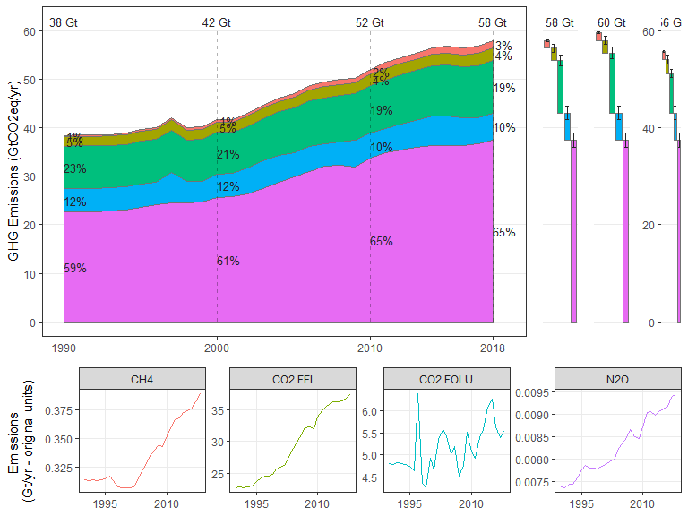

**Please note!**

* Let’s aim for a pragmatic solution in SOD mainly focused on subsectors
* Happy to provide these figures and be part of the process, but due to ongoing health problems we will not be able to devote a substantial amount of time to further developing customized figures, e.g. individual requests and many iterations.

